**Topics to cover**

a. Introduction to Python

b. Data types, expressions and statements

c. Control flow

d. Functions

e. Data types II

f. Files and exception,

g. Python modules and packages

**Introduction to Python**

Python is a general-purpose, high level programming language. It was designed by Guido van Rossum in 1991 and developed by Python Software Foundation. Python is a programming language that lets you work quickly and integrate systems more efficiently.

Features/Advantages of Python

1. Python is an object-oriented programming language: its structure supports concepts such as polymorphism and inheritance.
2. It is free (an open-source programming language): downloading and installation is free
3. Python has many built-in types and tools
4. Python has many library utilities and third-party library utilities such as NumPy, SciPy to make programming easier
5. Python is easy to learn and use
6. It is portable: it can run easily on any machine and operating system and is platform independent.
7. It is an interpreted language. (i.e., python is processed at runtime by the interpreter).

Data Types

The following are data types that facilitate the storage and manipulation of data in the memory.

1. Int (integer, positive or negative whole number)
2. Float (a positive or negative number that contains one or more decimals)
3. Boolean (true or false)
4. String (a continuous set of characters bounded by single or double quotation marks)
5. List (a general-purpose collection of various data types)

**Nota bien**

1. Suppressing Special Character:

Using a backslash (\) in front of the quote character in a string “escape” it and causes Python to suppress its usual special meaning. It is then interpreted simply as a literal single quote character

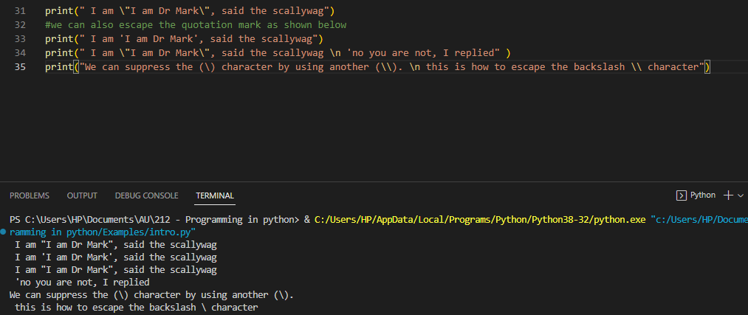

1. Comments:

Single-line comments begins with a hash(#) symbol which indicates that the whole line should be considered as a comment

A Multi line comment is indicated by triple double quote(“ “ “) or single quote(‘ ‘ ‘)